2024

Yashaswi.G

3/18/2024

Report of Capstone

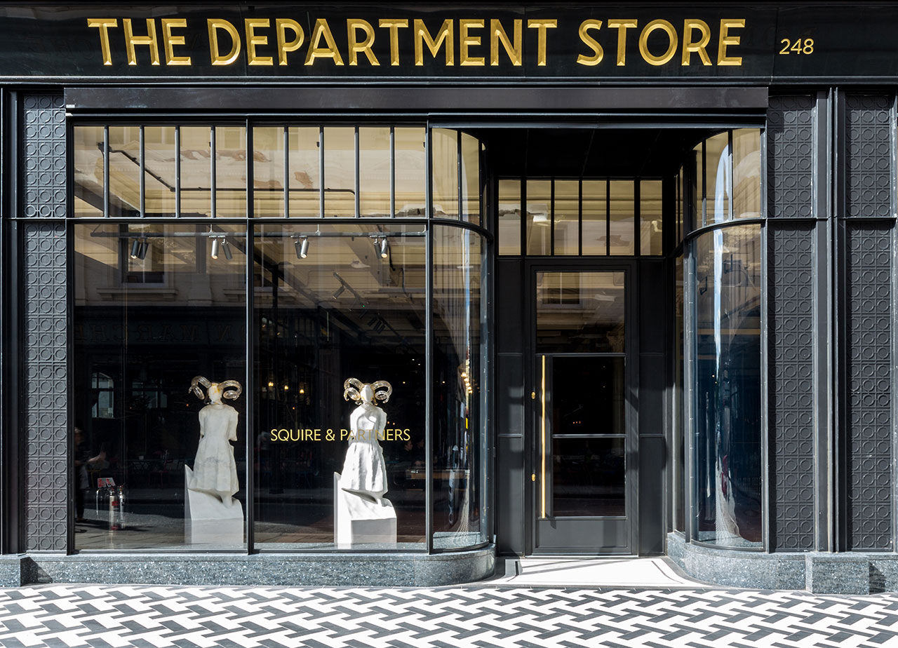

Q1) **Top Categories by Total Price:**

* + 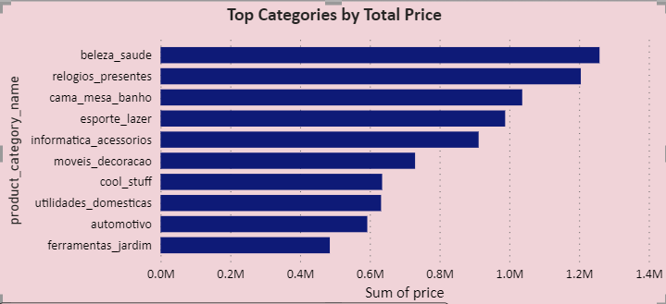Identify and visually represent the top 10 product categories by total sales.

**Insights:**

1. Top Revenue Generating Categories:
   * Identify the top revenue-generating product categories based on the sum of prices. In this case, "beleza_saude," "relogios_presentes," and "cama_mesa_banho" appear to be the top three categories with the highest total revenue.
2. Lowest Revenue Generating Categories:
   * Identify the product categories with the lowest revenue generation. "ferramentas_jardim" and "automotivo" seem to be among the categories with comparatively lower revenue.
3. Strategic Decision-Making:

* strategic decision-making processes, such as resource allocation, marketing strategies, inventory management, and product development initiatives are essential for optimizing sales performance.

Q2) **Delayed Orders Analysis:**

* 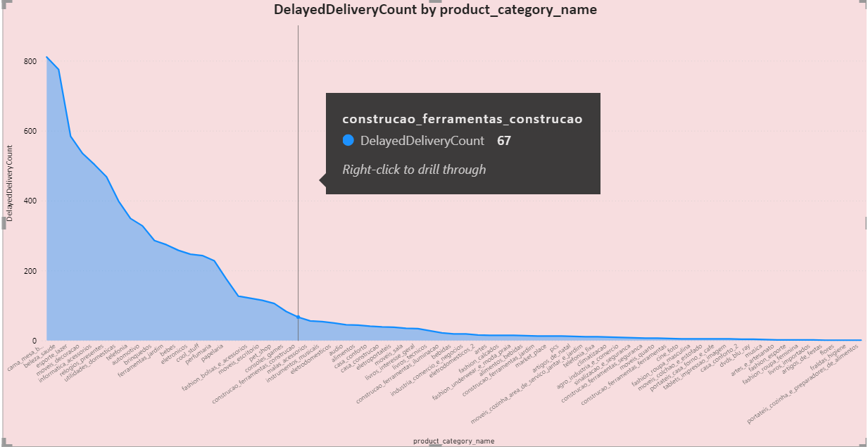Determine the number of delayed orders in each category. An order is considered delayed if the actual delivery date is later than the estimated delivery date.

**Insights:**

1. Cama_mesa_banho has the most delayed delivery with a count of 769.
2. Artigos_de_festas, flores, fraidas_higiene, portateis_cozinha_e_preparador_es_de_alimentos has the least delayed delivery with count of one each.
3. The products might be delivered according to the availability and location of goods.
4. Issues in Logistics and improper supply chain management can be the reasons for delay in delivery of goods.
5. Proper resource allocation is important for on-time delivery of goods and products to different locations.

**Q3) Monthly Comparison of Delayed and On-Time Orders:**

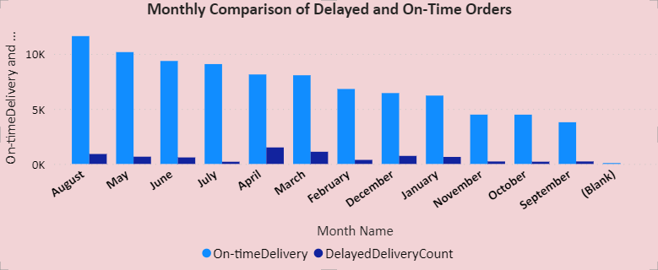Create a dynamic visual that compares the number of delayed orders to the number of orders received earlier for each month. Utilize the drillthrough cross-report feature to provide a detailed analysis of late and on-time deliveries.

**Insights:**

1. **Monthly Delayed Delivery Trends:** April, March, and August appear to have the highest counts of delayed deliveries, indicating potential issues or challenges during these periods.
2. **Comparison with On-Time Deliveries:** March and August have high counts of delayed deliveries, they also have relatively high counts of on-time deliveries, suggesting a balanced performance despite challenges.
3. **Seasonal Variations:** December and May show relatively higher counts of delayed deliveries compared to other months, which could be attributed to factors such as increased order volumes during holiday seasons or specific events.

**Q4) Payment Method Analysis:**

Analyze the most frequently used payment methods by customers using a visually appealing representation, such as a pie chart or other suitable visuals.

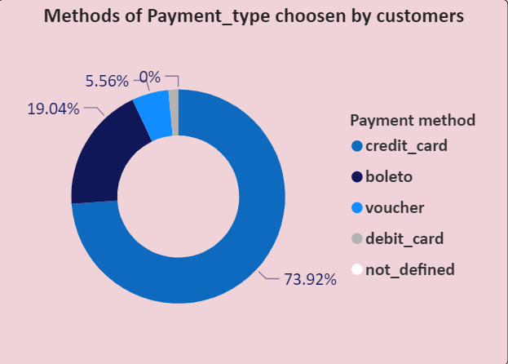

**Insights:**

1. **Prevalence of Credit Card Payments:** Credit card payments appear to be the most commonly used payment method, with a significantly higher count compared to other payment types. This indicates that a majority of customers prefer using credit cards for their transactions.
2. **Significance of Boleto Payments:** Boleto payments, although fewer in count compared to credit card payments, still represent a substantial portion of the total transactions.
3. **Limited Usage of Debit Cards:** Debit card payments have a relatively low count compared to other payment types, indicating that customers may prefer using credit cards or boleto over debit cards for their transactions.

**Q5) Product Rating Analysis:**

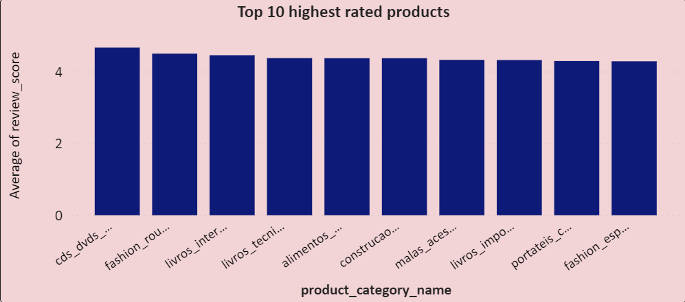Determine the top 10 highest-rated products and the bottom 10 lowest-rated products using a bar or column chart.

**These are the top 10 highest rated products**

**Insights:**

1. **High Average Review Scores:** The majority of the top 10 product categories have high average review scores, with ratings ranging from 4.29 to 4.67. This indicates overall positive feedback and satisfaction among customers for products within these categories.
2. **Popular Categories with Positive Feedback:** Categories such as "cds_dvds_musicais," "fashion_roupa_infanto-juvenil," and "livros_interesse_geral" appear to be popular among customers, as they have high average review scores**.**
3. **Competitive Advantage:** Categories with consistently high average review scores can be leveraged as a competitive advantage.

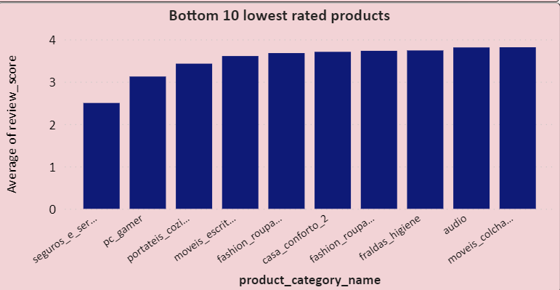**These are the bottom 10 lowest-rated products**

**Insights:**

1. **Lower Average Review Scores:** The bottom 10 product categories have relatively lower average review scores compared to higher-rated categories, with ratings ranging from 2.50 to 3.82. This indicates that these products may have received less favorable feedback from customers.
2. **Areas Requiring Improvement:** The categories with lower average review scores, such as "seguros_e_servicos" and "pc_gamer," may indicate areas where improvements are needed.
3. **Customer Dissatisfaction:** Lower average review scores suggest that customers may be less satisfied with products within these categories
4. **Product Quality Issues:** Categories with consistently low average review scores, such as "fraldas_higiene" and "audio," may indicate potential product quality issues or shortcomings.

**Q6) State-wise Sales Analysis:**

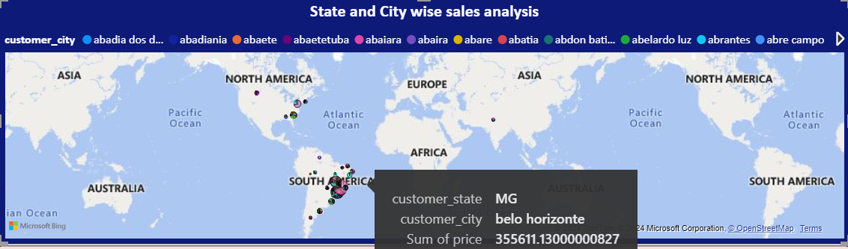Identify and visually represent states with high and low sales, providing a clear understanding of regional sales performance.

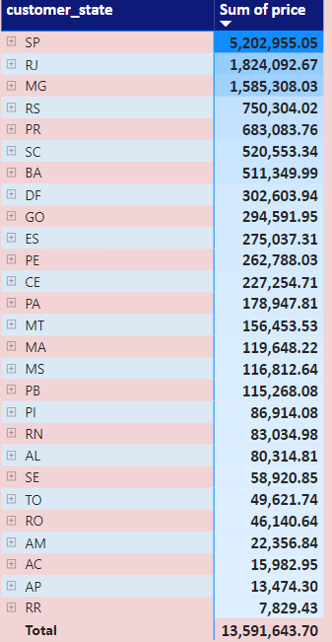

**Insights:**

1. **Revenue Distribution by State:**

States like SP, RJ, and MG appear to contribute significantly to the total revenue, with the highest sums of prices.

1. **Regional Revenue Patterns:**

States in the Southeast region (e.g., SP, RJ, MG) of South America tend to have higher revenue compared to states in other regions.

1. **Customer Concentration:**

Higher revenue states may have larger customer bases or higher average order values, while lower revenue states may have fewer customers or lower purchasing power.

1. **Marketing and Sales Strategies:**

Tailor marketing and sales strategies to target specific regions or customer segments based on revenue patterns. Allocating resources and investments strategically to maximize ROI and capitalize on opportunities for growth helps in maximizing profits.

1. **Customer Satisfaction and Retention:**

Monitoring customer satisfaction and retention rates across different states helps in understanding customers better. Higher revenue states may indicate stronger customer loyalty and satisfaction, while lower revenue states may require additional efforts to enhance customer experiences and loyalty.

Q7) **Seasonal Sales Patterns:**

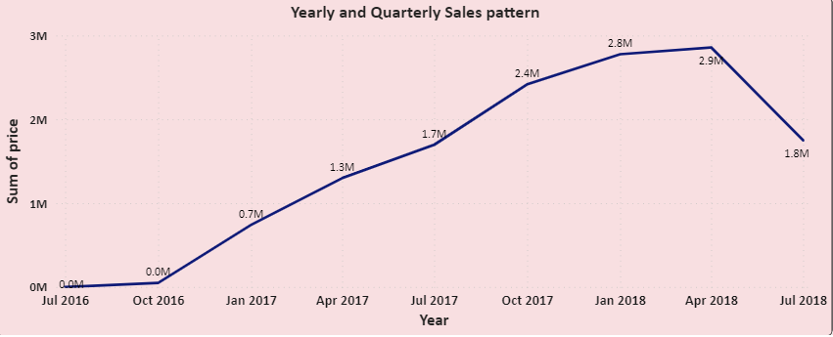Investigate and visualize any seasonal patterns(Quarterly) or trends in sales data over the course of the year.

**Insights:**

1. The sales peaked in the 2nd quarter of 2018 with a total sum of around 2.9M which is then followed by the 1st quarter of 2018 with a total sum of 2.8M.
2. There’s a gradual increase in sales from the 4th quarter of 2016 to the 2nd quarter of 2018 which suggests that there’s an increase in the overall sales performance of the stores.
3. There’s a steady decrease in sales from the 2nd quarter of 2018 to the 3rd quarter of 2018 which indicates the need for a proper marketing campaign to boost overall sales.
4. The overall increase in total sales suggests that the brand is well recognized and had a good impact on retaining customers which boosts customer satisfaction.
5. Strategic planning and proper allocation of resources might help in improving the sales and profit of the company in long run.

**Q8) Revenue Analysis:**

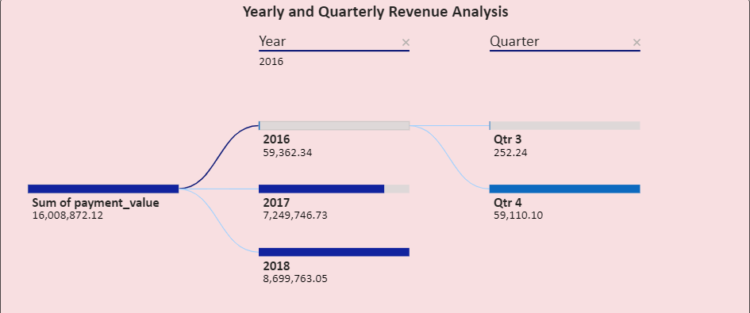Determine the total revenue generated by ShopNest Store and analyze how it changes over time(Yearly). Represent this information through suitable visuals to highlight trends and patterns.

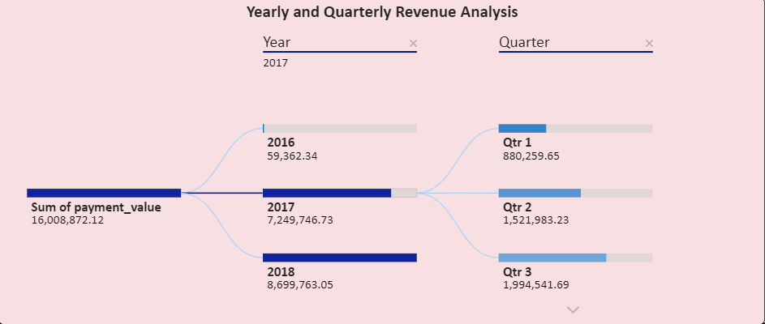Revenue generated in the year 2016 in 3rd and 4th quarters

Revenue generated in the year 2017

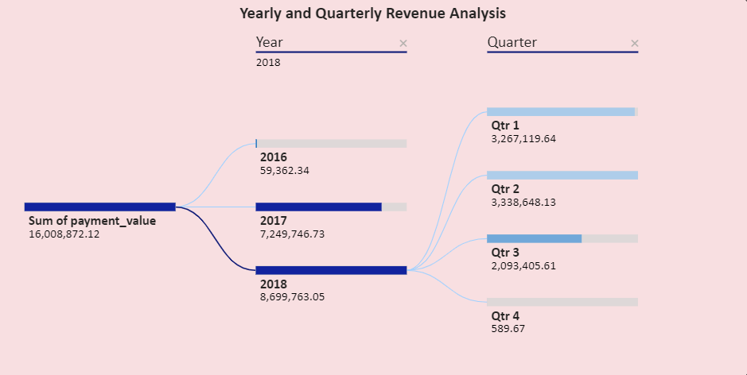Revenue generated in the year 2018

**Insights:**

1. **Yearly Revenue Trends:**

The data shows an increasing trend in revenue from 2016 to 2018, indicating growth and expansion in sales.

1. **Quarterly Revenue Distribution:**

Each year is divided into four quarters (Q1, Q2, Q3, Q4), and the data shows variations in revenue across quarters within each year. The revenue is increasing from quarter to quarter within each year.

1. **Quarterly Performance Analysis:**

Q4 tends to have the highest revenue in both 2017 and 2018, possibly due to holiday season sales and promotions.

1. **Forecasting and Planning:**

Understanding past performance can help in setting realistic revenue targets and allocating resources effectively.

THANK YOU